Maintenance Guide
For Aboveground Pools
(SOFTSWIM POOLS)

Includes:

General Operations page 2

Backwashing page 3

Vacuuming page 4

Water Testing/Pool Maintenance page 5

Pool Chemicals page 6-8

Troubleshooting page 8


3117 S. Campbell Ave Springfield, MO 65807
(417) 883-8827

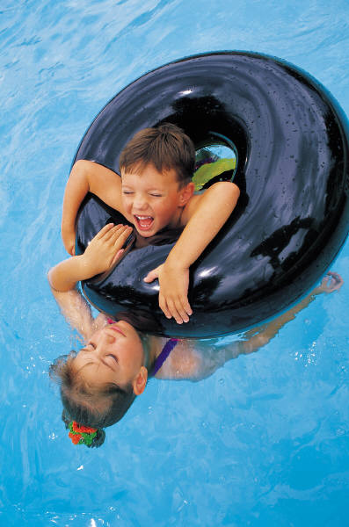

General Operations & Maintenance

Skimmer and pump baskets should be checked and/or emptied every 3-4 days. If you have a lot of trees, you may want to do this daily during the summer.

The water should always be halfway up on the skimmer mouth.

Never turn pool lights on when pool is drained. Lights should be turned on only when they are submerged.

The pump and filter should never run without water in both. If the pressure gauge indicates zero pressure, this indicates that there is no water moving through the pump and filter, and it is necessary to prime the pump.

To prime the pump:
- Turn off the pump.
- Close any ball valves (only if you have rigid PVC plumbing).
- Remove lid or pump strainer pot.
- Take garden hose and fill pot with water.
- Replace and tighten lid.
- Open main drain ball valve (only if you have rigid PVC plumbing).
- Turn on pump and wait until pressure builds to normal reading.
(If pump does not prime after about a minute, shut off and repeat above steps)
- Open skimmer ball valve slowly (only if you have rigid PVC plumbing).

Never add chemicals to pool while swimmers are in the water.

Absolutely do not mix chemicals.

Pool chemicals can be dangerous. Read all labels and use products according to directions. Store chemicals in a cool, dry place.

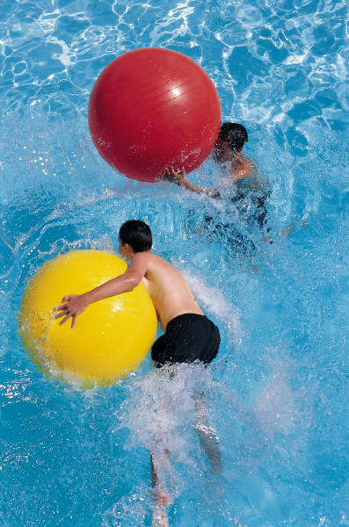
Backwashing (Cleaning Filter)

Backwashing your filter is very important, as it reverses the flow of water through the filter sand, rinsing the debris out of it. The pressure gauge for the filter should be positioned somewhere near the valve handle, and should be checked at least once a week.

Normal operating pressure will vary widely from filter to filter. To find what your norm is, backwash the filter thoroughly (about 2-3 minutes), then record below what the psi reads on your gauge when you start the filter back up.

Normal psi _____________

The filter should be backwashed when the pressure reaches 8 – 10 psi above normal, or once a week, whichever comes first. Sand in the filter should be replaced every 3 – 5 years on a chlorine system, and every year on a Softswim system.

Filters will not be damaged by backwashing more frequently. If you are having problems with hazy or green water, backwash the filter daily. This will help get rid of bacteria and algae in the water faster.

To backwash sand and DE filters with multi-port valves:
- Turn off pump.
- Turn valve handle to backwash.
- Roll out backwash hose.
- Turn on pump.
- Allow filter to backwash until water clears in sight glass (45-60 seconds).
- After water clears, turn pump off.
- Turn valve handle to rinse.
- Turn on pump.
- Allow filter to rinse for 30 seconds.
- Turn off pump.
- Return handle to filter position.
- Turn on pump.

NOTE: Repositioning multi-port valve while pump is in operation may cause damage to the filtering system. Always shut pump off first.

All ball valves should be open while backwashing.



Manual Vacuuming

If you have an automatic cleaner, please skip to step 19. Refer to your cleaner’s instruction manual for details on how to install.

- Keep valve handle on filter position.
- Close main drain ball valve (for rigid PVC plumbing only).
- Attach vacuum head to pole.
- Attach vacuum hose to vacuum head.
- Place head and hose in the water.
- Feed vacuum hose straight down into the water, allowing hose to fill with water.
- Keeping free end of vacuum hose in the water, move to the skimmer and attach hose to vac plate set over skimmer basket.
Doughboy pools only: Take skimmer lid off of top of skimmer, angle and place down snugly over skimmer basket. Once hose has filled, insert vacuum adapter in the end of hose, and plug other end of adapter into the hole beneath the skimmer.
- Vacuum pool.
- After vacuuming is finished, remove vacuum hose from skimmer.
- Turn off pump.
- Shut off skimmer ball valve (rigid PVC plumbing only).
- Remove skimmer basket and empty. Check pump strainer basket and empty if needed.
- Replace basket and lid (for Doughboy, replace lid in normal position on top of skimmer.)
- Open all ball valves (rigid PVC plumbing only).
- Turn on pump and allow pressure to build.
- Backwash the filter. (see previous page)
- Remove vacuum equipment from the pool.
- For proper vacuuming suction, it is important that the filter is clean prior to vacuuming. If necessary, backwash before vacuuming also. Check and make sure pressure gauge is reading within normal psi before starting to vacuum.
- Once a week the pool should be brushed down with a vinyl bristled pool brush before vacuuming. This will loosen any molecules that might be stuck to the walls or floor.

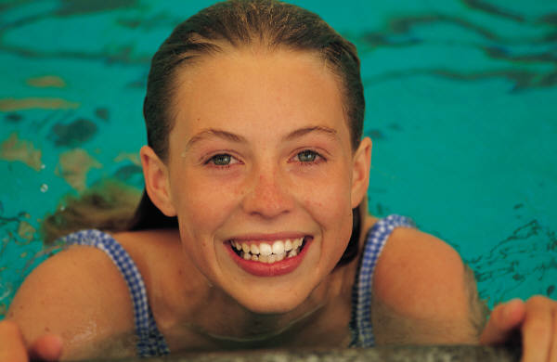

Water Testing and Maintenance

Pool water should be tested with Softswim 4-way test strips at least once a week.

When testing with test strips, take one strip out of bottle, and screw lid back onto bottle. (This eliminates the chance of leaning over the pool with the bottle in your hand and dumping all 50 strips in the pool!)
Dip your strip into the water, away from the jet return, and immediately bring strip back out of water and hold level for 30 seconds. After exactly 30 seconds, match colors on strip to colors on back of bottle for Total Alkalinity, pH, and Softswim C. After comparing colors in that order, re-dip the strip and rapidly swish strip back and forth underwater for 30 seconds. After 30 seconds, bring strip back up and compare color for Softswim B (biguanide). Adjust pH and total alkalinity if necessary, according to directions in Chemicals section. If Softswim B level is more than 50 ppm, no Softswim B should be added for that week.

Recommended levels for pool:

Softswim B (sanitizer) 30 - 50 ppm
Softswim C (shock) 40 – 60 ppm
PH 7.2 – 7.6
Total Alkalinity 125 – 150 ppm

Bring in a 12 oz. water sample for free computerized analysis at least once a month during the summer season.

Cleaning and Maintenance

The pool walls need to be brushed once a week. Use the vinyl bristled brush on the end of your telescoping pole, or get in and brush while you swim!

Vacuum pool as needed to keep floor clean. The less debris in the water, the less chemicals you’ll use. An automatic pool cleaner comes in handy here!

If you have a solar blanket, make sure you take it off the pool every 2 – 3 days so the pool can breathe, and gas off bacteria that has been killed.

The best thing you can do to keep your pool clear is run the pump and filter system 24 hours a day, every day. Filtration is very important to water clarity. Follow the directions for the 3 Step Program below, and you will have a sparkling pool all summer long! (And that’s what you bought it for, right?)

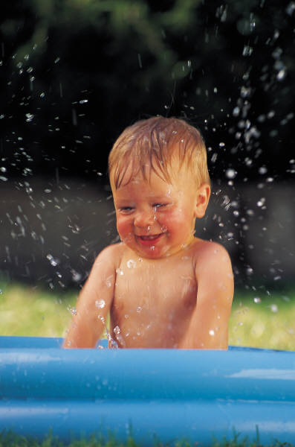

Pool Chemicals

Basic chemicals you will need to have on hand:

Chemical What It Does
Step 1: Softswim B Sanitizer for pool, added weekly if necessary. Test first!
Step 2: Softswim C Oxidizes bacteria out of water, added every two weeks
Step 3: Softswim A Helps prevent algae, added weekly
Softswim Filter Cleaner Used to clean filter media, use every six weeks.
Lo N Slo Ph and Total Alkalinity Decreaser
Balance Pak 200 Ph Increaser
Balance Pak 100 Total Alkalinity Increaser
Off the Wall Pool wall and skimmer cleaner
Test Strips Test for Softswim B, C, ph, total alkalinity

Spring Start Up and/or Fresh Fill

First: Above ground pools should never be completely drained, unless the liner is being replaced. The pool needs water to support the sidewalls, and keep the vinyl liner soft and pliant. Pools can be partially drained if fresh water is needed.

Step 1: Replace filter sand in tank. This must be done every year on a Softswim system.

Step 2: If water is clear, follow these instructions:
- Add Softswim C directly to the pool with the pump running. Add 1 gallon per 10,000 gallons of pool water.
- Add Softswim B directly to pool with pump running. Use 1 bottle (1/2 gallon) per 10,000 gallons of pool water.
- Add Softswim A algaecide directly to pool. Use 1 ounce per 1,000 gallons of pool water.

If water is cloudy or green, follow these instructions:
- Add Softswim C directly to the pool with the pump running. Add 2 gallons per 10,000 gallons of pool water.
- Add Softswim B directly to pool with pump running. Use 1 bottle (1/2 gallon) per 10,000 gallons of pool water.
- Add Algae All 60 algaecide directly to pool. Use 2 ounces per 1,000 gallons of pool water.

ALWAYS run pump 24 hours per day if water is not clear. This will help water clear faster. Backwash every 24-48 hours as needed to relieve filter pressure.

ABC Program for Weekly Maintenance

Step 1: Add Softswim A directly to the pool. Usage:
Pools 12’ to 21’ 2 oz per week
Pools 24’ to 28’ 3 oz per week
Pools 30’ and up 4 oz per week

Step 2: Test water. Add Softswim B if biguanide level is lower than 50. Add directly to pool water with pump running. To raise the B level by 10 ppm (multiply as necessary to raise desired amount):
Pools 12’ to 18’ 1 pint
Pools 21’ to 24’ 1 ½ pints
Pools 28’ to 30’ 2 pints
Pools 32’ and up 2 ½ pints

Step 3: Add Softswim C directly to the pool every two weeks. Usage:
Pools 12’ to 18’ Add 1 gallon every two weeks
Pools 21 to 24’ Add 1 ½ gallons every two weeks
Pools 28’ to 30’ Add 2 gallons every two weeks
Pools 32’ and up Add 3 gallons every two weeks

If pool water is cloudy or green, or no Softswim C level is present, bring a sample into our store for accurate analysis as soon as possible. Pink slime or water mold may be present and will require special treatment.

Always remember to take care when handling and storing chemicals. Store opened bottles in a cool, dry place. Avoid getting chemicals on skin, hair or eyes.

Balancers: Test water with test strips at least once a week. Dip strip into water, and hold strip level for exactly 30 seconds. This is very important to get accurate levels. Adjust pH and total alkalinity if necessary. Lo N Slo and Balance Pak 200 should only be added when the test strip indicates the pH is off. These products will raise or lower pH. Add products per directions on back of bottle, or bring a water sample in to the store to be tested.

If there is ever a problem with your water, or if you just want to check yourself, we test water every day for FREE! Bring a 12 oz sample in, and we’ll let you know how you’re doing.

STEP 4: MOST IMPORTANT. For your own sanity and overall well-being, get into the pool and swim around at least 30 minutes each day. Get the kids, have a huge splash fight. You’ll remember why you wanted this pool in the first place!

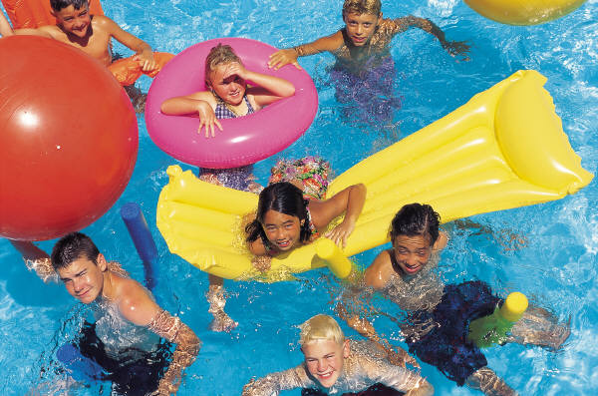

Troubleshooting Tips

Most problems with the pool can be easily fixed yourself. Some common problems and solutions are:

Problem: Pool leaking around equipment area.
Solution: Tighten clamps on all connecting hoses. Make sure drain
plugs are tightly installed on sand filter tank and pump.
Make sure pump lid is on tight and o-ring is seated correctly.

Problem: Pool filter pressure running too high, water pressure weak
at return jet.
Solution: Filter needs to be backwashed. If you have recently backwashed
already, try backwashing for longer, 2-3 minutes. Remember, sand
also needs to be replaced every 3 – 5 years.

Problem: Pool filter pressure low or zero, and/or bubbles coming out of
return jet.
Solution: Make sure water level in pool is at mid-skimmer. Make sure skimmer
itself is full of water. Make sure pump basket is full of water, and water
is circulating through system. If you can see water churning in pump
basket, there is air getting into system. Check hoses for pinholes,
tighten clamps on hose from skimmer down to pump. Also check
pump lid and o-ring for cracks, lid or o-ring may need to be replaced or
lubricated. Make sure pump lid is tightened securely.

Problem: Pool water making loud surging or gurgling noise.
Solution: Water level in pool is probably low, add water to pool until it hits
mid-skimmer level.

